#Assignment: Setting Up Your Developer Environment

#Objective: This assignment aims to familiarize you with the tools and configurations necessary to set up an efficient developer environment for software engineering projects. Completing this assignment will give you the skills required to set up a robust and productive workspace conducive to coding, debugging, version control, and collaboration.

#Tasks:

**1.Select Your Operating System (OS):**

(a)Download and Install Windows 11

1. **Check System Requirements**: Ensure your PC meets Windows 11's minimum requirements.
2. **Backup Data**: Save important files to avoid data loss.
3. **Update Windows 10**: Go to **Settings > Update & Security > Windows Update** to update your current system.
4. **Download Installation Assistant**: Get it from the <https://www.microsoft.com/software-download/windows11>.

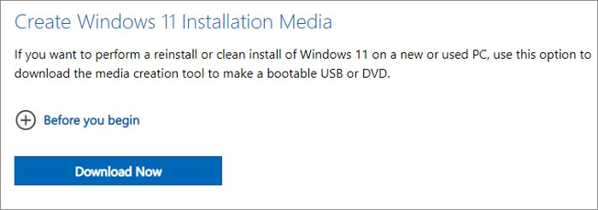

1. **Run Installation Assistant**: Follow the instructions to begin the upgrade.
2. **Media Creation Tool (Optional)**: Use it for a fresh install or multiple PCs by creating a bootable USB or downloading the ISO file.
3. **Install Windows 11**: Use the Installation Assistant or the Media Creation Tool and follow the on-screen prompts.

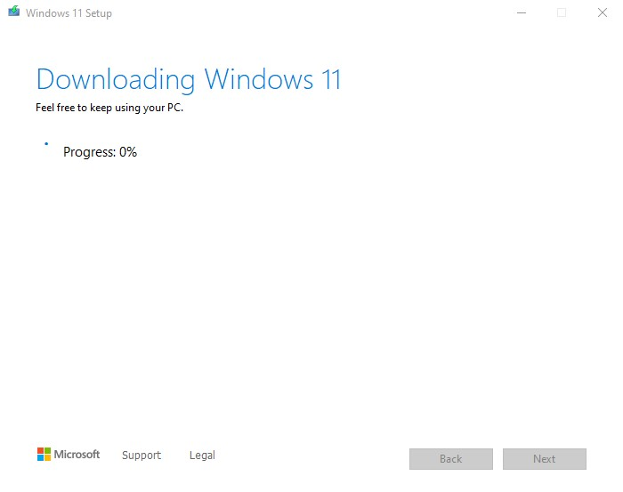

1. **Activate Windows 11**: Check activation status in **Settings > Update & Security > Activation**.
2. **Install Drivers and Updates**: Check for and install any necessary updates.

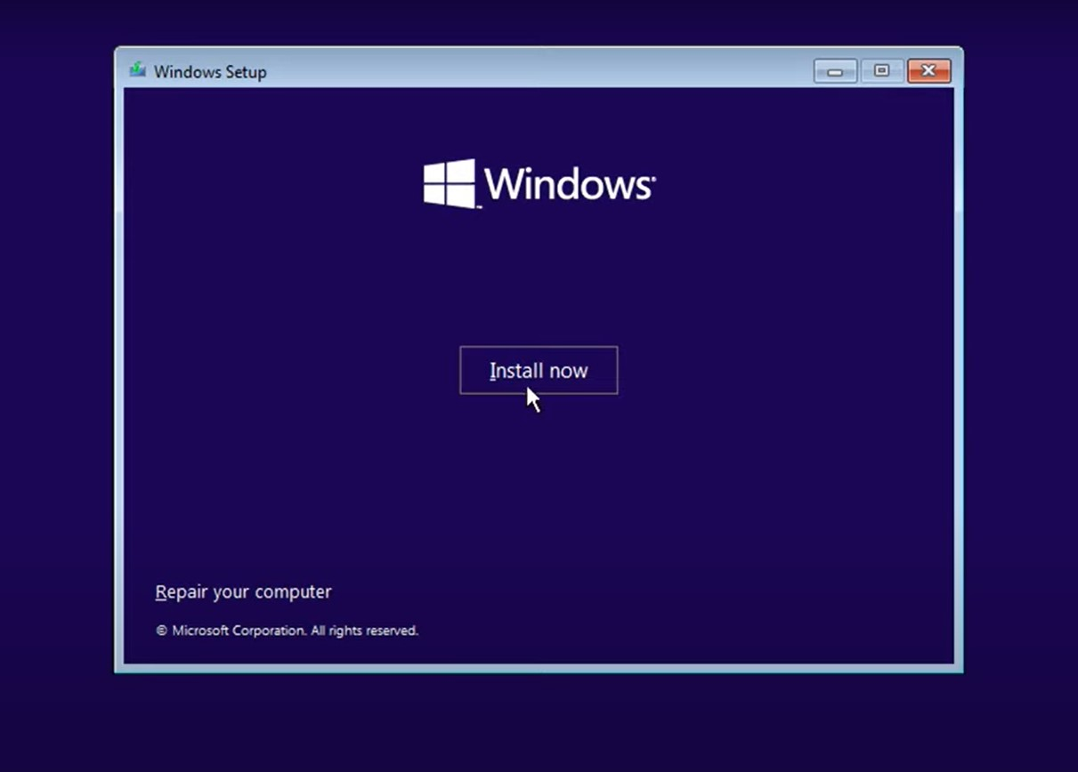

1. **Restore Data**: Restore your backed-up files.

### Install a Text Editor or Integrated Development Environment (IDE):

Select and install a text editor or IDE suitable for your programming languages and workflow. Download and Install Visual Studio Code. <https://code.visualstudio.com/Download>

**Steps to Download and Install Visual Studio Code on Windows**

1. Visit the Official Website: <https://code.visualstudio.com/Download>
2. Download VSCode:Click the download button for Windows to get the installer (.exe file).

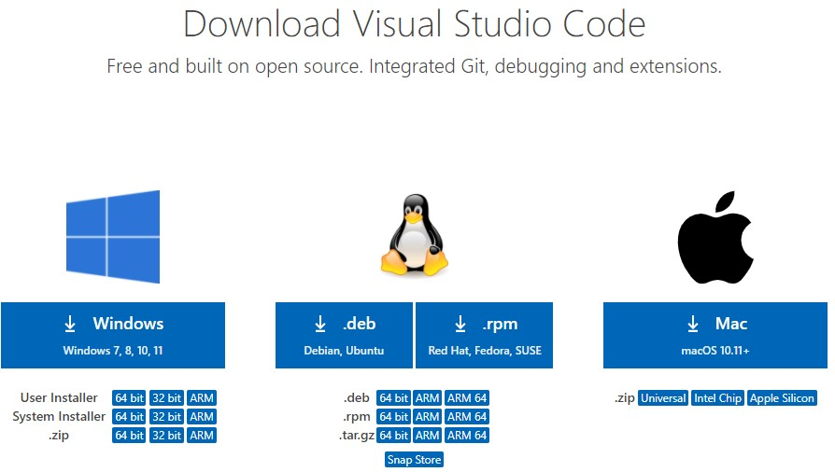

d. Click "Install."

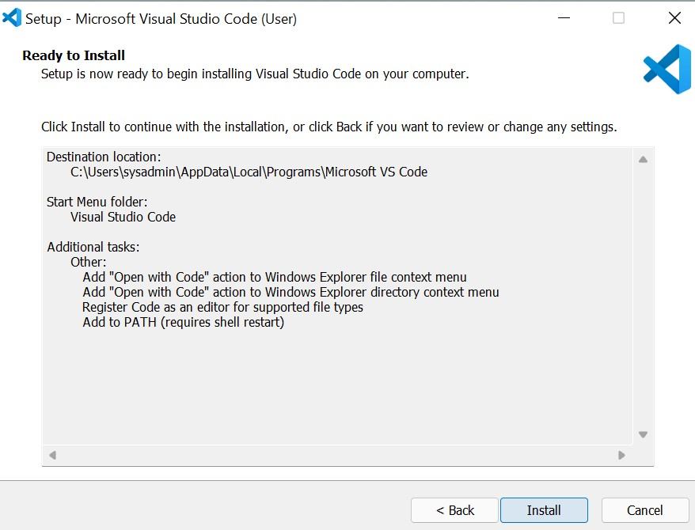

e. Launch VS Code : Click "Finish" to launch, or open it from the Start menu or desktop icon.

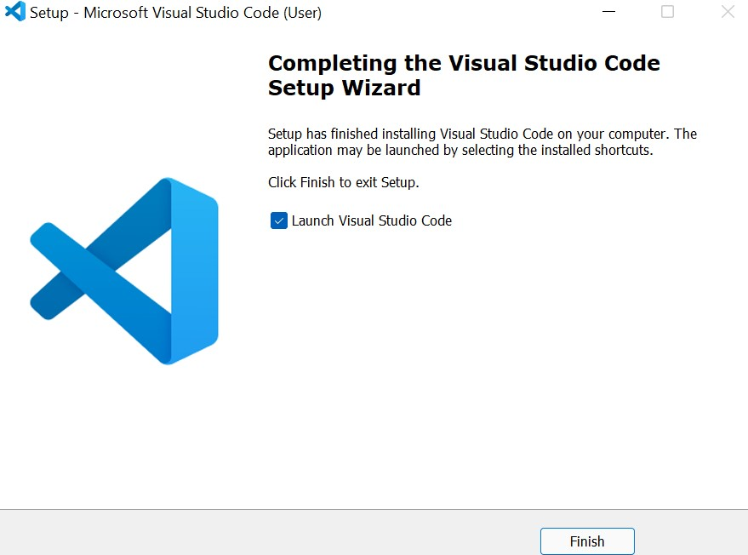

F. Install Extensions (Optional): Open VS Code, go to the Extensions view (Ctrl+Shift+X), and install desired extensions.

### Set Up Version Control System:

Install Git and configure it on your local machine. Create a GitHub account for hosting your repositories. Initialize a Git repository for your project and make your first commit. [https://github.com](https://github.com/)

1. Install Git: Download Git from the official Git website and follow the installation instructions for your operating system.

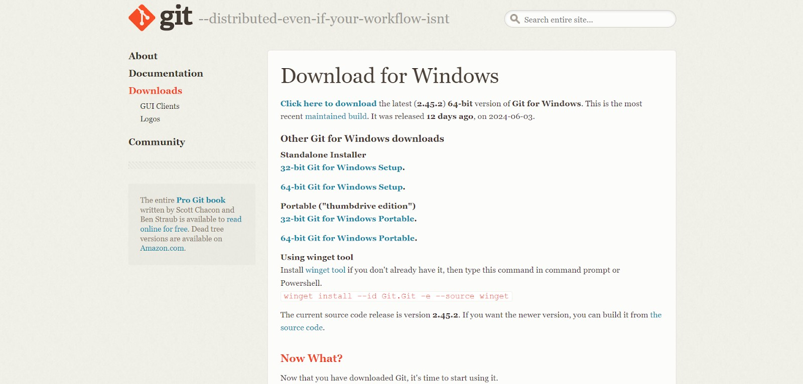

1. Run the installer and choose the location where you want the Git installation to be kept. Accept the default location and click next

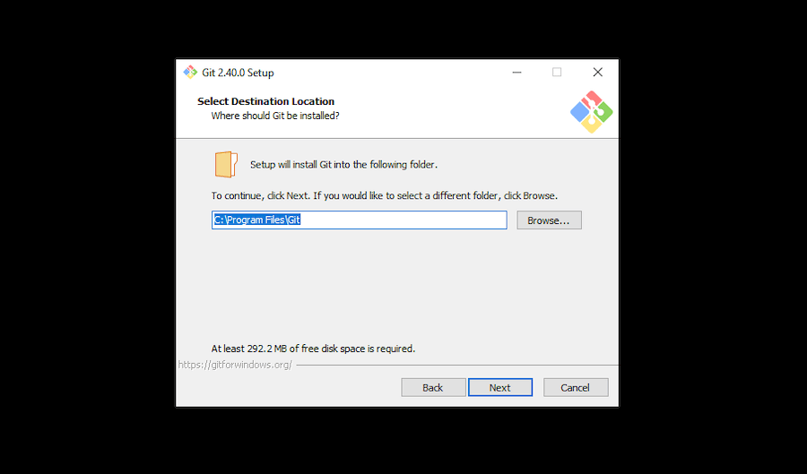

c. Follow the Installation Wizard:

* Choose the default options or customize the installation according to your preferences. Some key settings to note:
  + Adjusting your PATH environment.
  + Choosing the HTTPS transport backend.
  + Configuring the line-ending conversions.
  + Choosing the default Git editor.

d. Start folder: You’ll be prompted to create a start folder. Leave it as is and click Next.

e. Text editor: Choose a text editor to use with Git. Click on the drop-down menu to pick the text editor you like to use like Vim, Notepad++, etc, and click Next. In the next steps choose all default options and click finish.

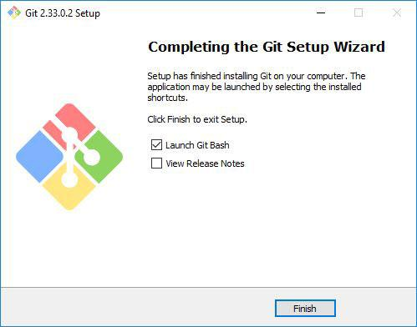

f. Verify the Installation: Open Command Prompt or Git Bash and run git –version



1. Steps in configuring git

Open a terminal (Git Bash).

Set your username and email: [git config --global user. name "Your Name"]

[git config --global user. email "[your.email@example.com](mailto:your.email@example.com)"]

1. Creating a GitHub Account

* Sign up for a GitHub account at GitHub. [https://github.com](https://github.com/)
* Enter your info:
  + Unique username
  + Email address
  + Password
  + Confirm password
  + Create GitHub account
* Click on the link to verify your email address.

1. Creating a new repository on GitHub:
   * Go to your GitHub profile page and click on your profile picture.
   * Go to your profile.
   * Click on your repositories.
   * Click on “Create new repository”.
   * Fill in the details:
     + Repository name
     + Repository description
     + Select “Public” to be accessed by everyone or private to avoid it being accessed by others.
     + Select “Initialize this repository with a README”(optional)
     + Add .git ignore (optional)
     + Click on “Create repository”.
     + Choose a license (optional)

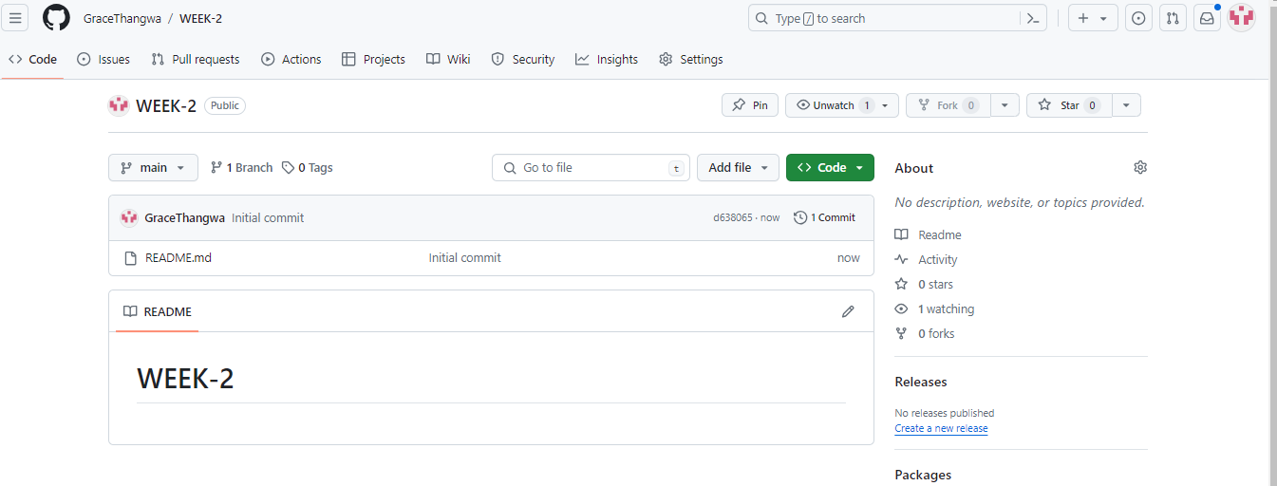

1. Cloning Git Repository

* Copy the repository URL from the GitHub page.
* Open Git Bash or Command Prompt.
* Run git clone [repository URL](https://github.com/Johnnytash/this-is-a-test-repo.git)
* navigate to the cloned repository and run git status to check if the repository is cloned successfully.
* verify the cloning with the ls command

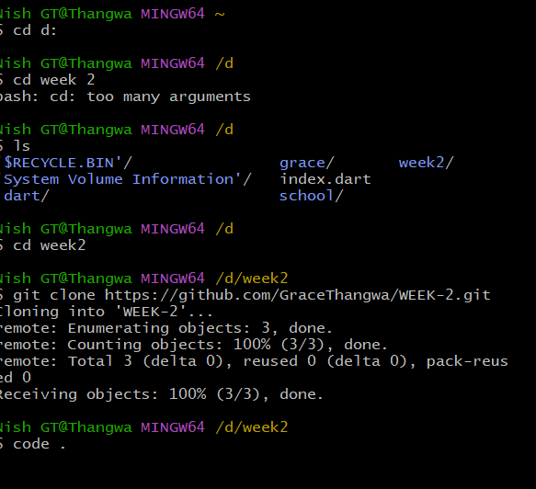

1. Commit and Push Changes

* Create a new file: [touch example.txt]
* Add content to the file: [nano example.txt]
* Save and exit the editor (for nano, press Ctrl+X, then Y, and Enter).

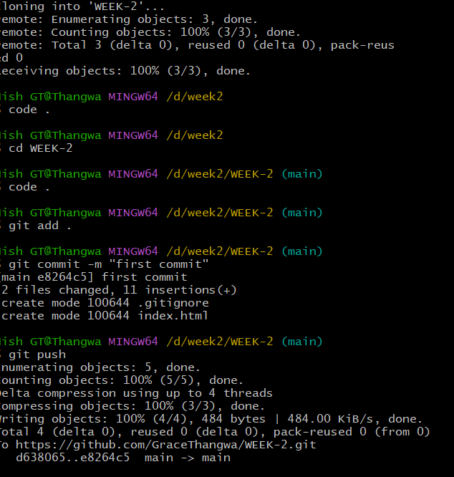

### Install Necessary Programming Languages and Runtimes: Python, Dart, and Flutter SDK

**Steps to Installing Python**

* 1. Download Python Installer: Go to the Python official website. [http://wwww.python.org](http://wwww.python.org/)

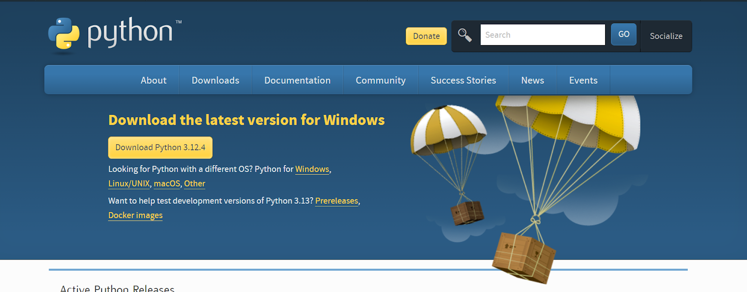

b. Run Python Installer: Once the download is complete, run the Python installer.

c. Customize Installation (Optional): During the installation process, you can customize the installation location and select additional features. It's recommended to check the box that adds Python to your system PATH, which makes it easier to run Python from the command line or terminal.

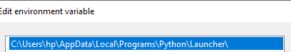

d. Install Python: Follow the prompts in the installer to complete the installation.

e. Verify Installation: Open a terminal or command prompt.

Type python --version and press Enter. You should see the installed Python version number, confirming that Python is installed successfully.

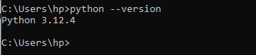

**Steps to installing Dart**

* 1. Download Dart SDK: Get the Dart SDK for Windows from the Dart website.

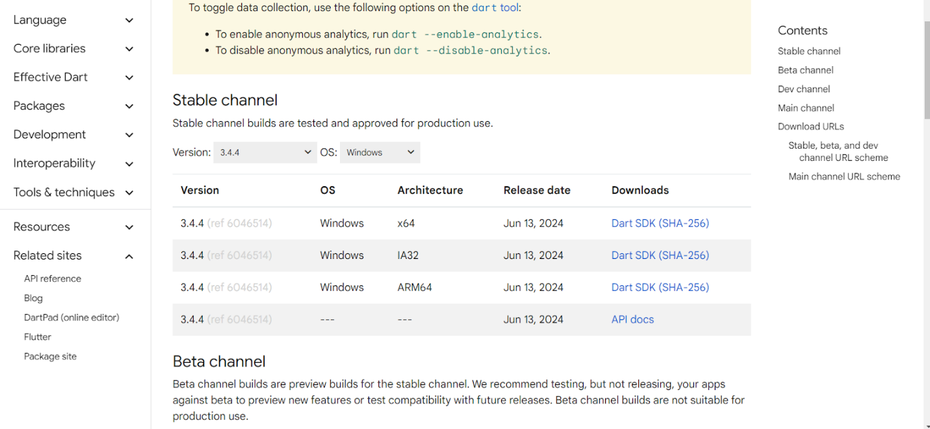

b. Run the Installer: Open the downloaded installer file (.exe) and follow the installation wizard.

c. Set Installation Location: Choose a location for Dart during the installation process.

d. Optional: Add Dart to System Path: To run Dart commands globally, add Dart's bin directory to the system PATH environment variable. 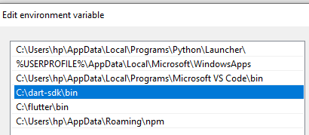

e. Verify Installation: Open a new command prompt and check Dart's version

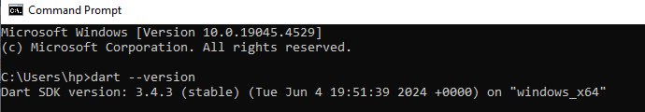

1. Optional: Set Up Development Environment:
2. Install dart and flutter extensions in vscode.

**Steps to Installing Flutter SDK**

* 1. Download Flutter: Visit the Flutter website and download the Flutter SDK for Windows.

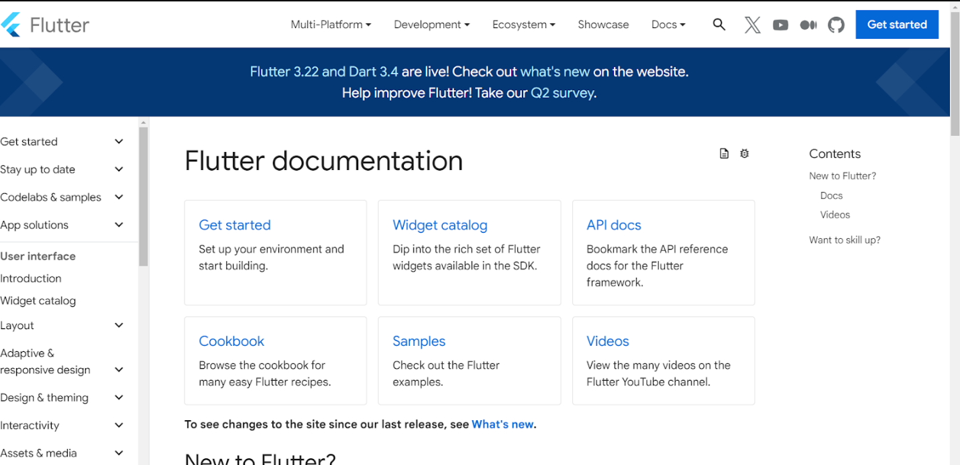

b. Extract Flutter: Once the download is complete, extract the downloaded ZIP file to a location on your computer where you want to store the Flutter SDK.

c. Set Up Environment Variables: Open the Start menu, search for "Environment Variables," and select "Edit the system environment variables."

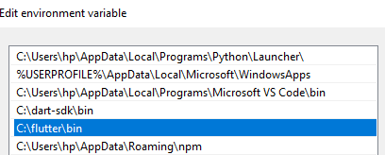

1. Verify Flutter Installation: Open a new terminal or command prompt. Run flutter --version to verify Flutter installation and see the Flutter version.

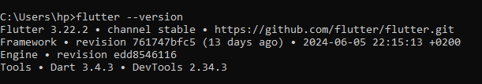

e. Set Up Flutter Doctor (Optional but Recommended): Run flutter doctor in the terminal to check for and install any missing dependencies needed for Flutter development.

f. Set Up an IDE (Optional): If using VS Code, install the Flutter extensions for enhanced development features.

**Steps to Installing MySQL**

•Download MySQL Installer: Visit the MySQL Community Downloads page. Select the appropriate version (usually MySQL Installer for Windows) and click the "Download" button.

• Run the MySQL Installer: Once the download is complete, run the MySQL Installer executable (.exe) file.

• Choose Installation Type: In the MySQL Installer window, choose the "Developer Default" or "Server only" installation type. The Developer Default option includes MySQL Server, MySQL Shell, MySQL Workbench, and other tools commonly used for development.

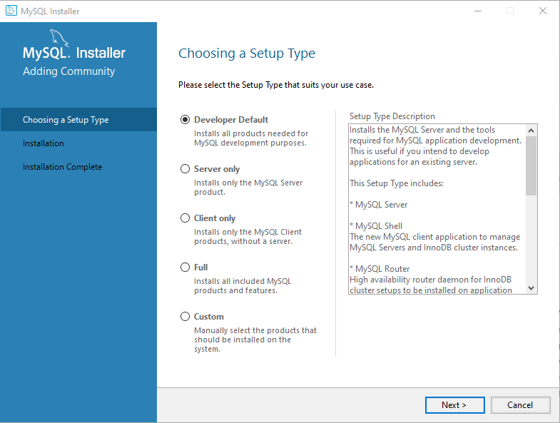

• Select Products to Install: In the Product Selection window, you can choose which MySQL products to install. For a basic installation, you can leave the default selections.

• Configure MySQL Server: During the installation process, you'll be prompted to configure MySQL Server. Set a root password for the MySQL Server. Make sure to remember this password, as it's required for administrative tasks.

• Complete the Installation: Follow the remaining installation steps, including choosing installation directories and starting the installation process.

• Verify MySQL Installation: Once the installation is complete, you can verify MySQL Server installation by opening a command prompt and running the following command: mysql –version This command should display the MySQL version if the installation was successful.

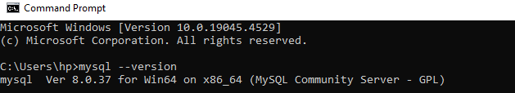

• (Optional) Configure Environment Variables: To use MySQL from the command line globally, you can add MySQL's bin directory to the system PATH environment variable.

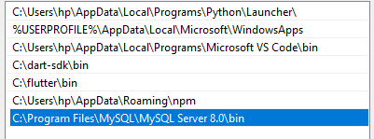

• Start MySQL Server (if not started automatically):MySQL Server may start automatically after installation. If not, you can start it manually using MySQL Workbench or the Windows Services Manager.

### Set Up Development Environments and Virtualization :

Download Docker Desktop: Get the installer from the Docker Desktop for Windows page.

• Run the Installer: Execute the downloaded installer (.exe).

• Enable Hyper-V and Containers Features: If not enabled, turn on Hyper-V and Containers in "Windows Features" and restart your computer.

• Install Docker Desktop: Follow the installation prompts.

• Launch Docker Desktop: Docker Desktop should launch automatically after installation.

• Test Docker Setup:Run a test container:

**Explore Extensions and Plugins:**

Explore available extensions, plugins, and add-ons for your chosen text editor or IDE to enhance functionality, such as syntax highlighting, linting, code formatting, and version control integration.

Visual Studio Code (VS Code) Extensions VS Code is a highly customizable text editor with a vast ecosystem of extensions. Here are some essential extensions:

1. Python: Provides IntelliSense, linting, and debugging for Python files.
2. Pylance: Enhances Python language support.
3. ESLint: Detects and fixes linting issues in JavaScript and TypeScript files.
4. Stylelint : Detects and fixes style issues in CSS and SCSS files.
5. Prettier: Formats code automatically based on defined rules.
6. GitLens: Visualizes and provides Git integration.
7. Docker: Manages Docker containers, images, and Docker files within VS Code.
8. SQL Tools: Interacts with databases directly from VS Code.
9. C/C++: Enhances C/C++ language support.
10. HTML CSS Support: Enhances HTML/CSS development with class name completion and live previews.
11. IntelliSense for CSS class names in HTML: Adds autocomplete for CSS class names.
12. Code Runner: Runs code snippets or entire files directly from VS Code.
13. Live Server: Launches a local server with live reload for static and dynamic pages.
14. HTML Snippets: Provides quick access to common HTML code snippets.
15. CSS Peek: Navigate to CSS definitions from HTML files.
16. Live Server: Launches a local server with live reload for static and dynamic pages.

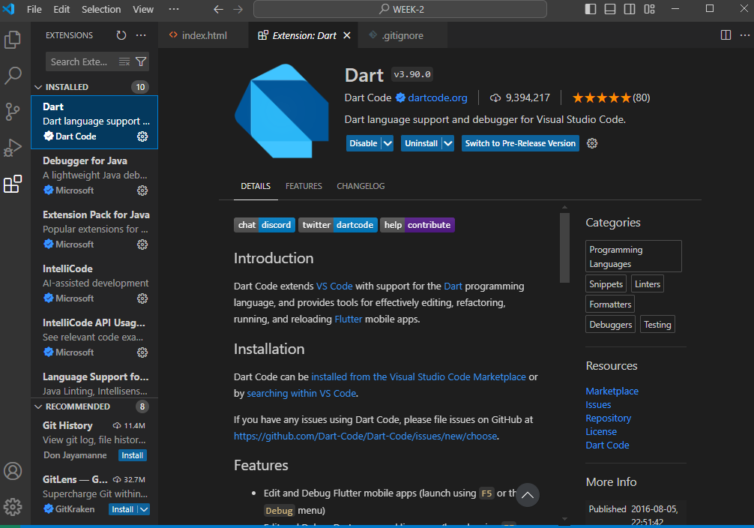

**Reflection on Challenges**

**Challenges Faced:**

• Docker: Installing and configuring Docker was quite challenging

• MySQL Installation: Configuring the MySQL server and setting up the root password was challenging without prior database experience.

• Flutter doctor installation was very tiresome due to some errors.

**Solutions:**

• Docker: Followed detailed tutorials and referred to Docker documentation From Youtube

• MySQL: Used MySQL official documentation and community forums for troubleshooting and watched several tutorials eg <https://www.youtube.com/watch?v=BxdSUGBs0gM&pp=ygUgbXlzcWwgaW5zdGFsbGF0aW9uIG9uIHdpbmRvd3MgMTE%3D>

**Sample github repository:**

<https://github.com/GraceThangwa/WEEK-2.git>

### Document Your Setup:

Create a comprehensive document outlining the steps you've taken to set up your developer environment. Include any configurations, customizations, or troubleshooting steps encountered during the process.

#Deliverables:

* Document detailing the setup process with step-by-step instructions and screenshots where necessary.
* A GitHub repository containing a sample project initialized with Git and any necessary configuration files (e.g., .gitignore). <https://github.com/GraceThangwa/WEEK-2.git>
* A reflection on the challenges faced during setup and strategies employed to overcome them.